Chapter 1: Science toolkit

1.1 Science laboratories contain hazards

Literacy support worksheet answers (pages 2–3)

Safety in the science laboratory

1 What is a hazard?

A hazard is anything that has the potential to put your health and safety at risk.

2 When is a chemical considered hazardous?

A chemical that is dangerous for a person to touch or inhale is considered hazardous.

3 What should you wear when working with chemicals?

a Buttoned up lab coat

b Safety glasses

c Long hair tied back

d Closed-toe shoes

e Gloves when necessary

4 Draw a picture of someone wearing the right clothing for working with chemicals. Use Figure 1.1 to help you.

Student responses will vary. Items from Question 3 above should be included in students’ drawings.

5 When observing chemical reactions what are two things you should never do?

a Never lean over any open containers.

b Never breathe in any gases that may be produced.

6 Why can’t chemicals be disposed of down the sink?

Some chemicals react with acid traps in in drains or are toxic for the environment

7 How would you dispose of the following materials:

a Olive oil

Collect in a bottle and dispose of in regular waste

b Plasticine

Place in regular rubbish

c A dilute acid

Pour down the drain

d A rat in a dissection

Teacher collects solids, deactivate liquid with bleach for 30 minutes, pour down drain

e Ammonia (a base-alkali)

Neutralise the alkali (with acid) and pour down drain

f Untreated Eucalyptus leaves

Place in regular rubbish

Word detective

8 Matching meaning

Draw a line from the picture to its description.

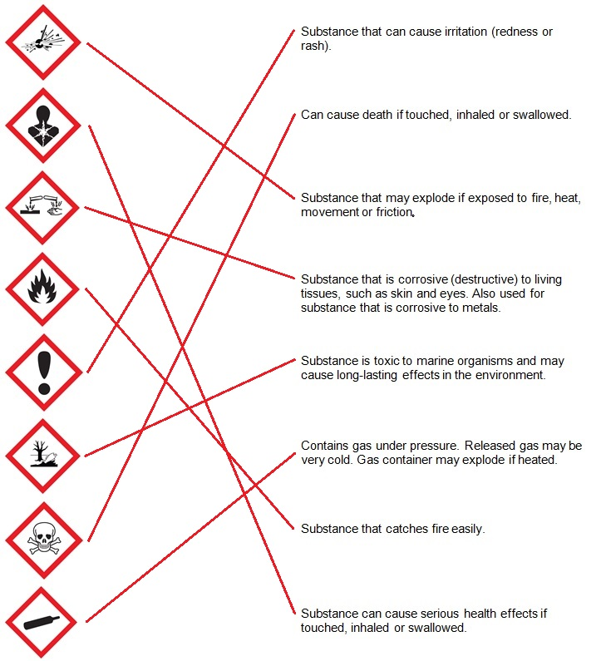

1.2 Dissection is an important science skill

Literacy support worksheet answers (pages 4–5)

Dissection

1 What is dissection?

Dissection is the process of cutting apart and observing something to study it. It requires the use of specialised equipment and techniques.

2 What are the four main pieces of specialised equipment that is required to perform a dissection?

Scissors, probe, scalpel and forceps or tweezers

3 Fill in the gaps using the information in the book.

|  |  |
| --- | --- |
|  | Name: Scissors  Function: Used for cutting skin and other tissue. Have rounded tips, which are less destructive to the tissue being cut. |
|  | Name: Probe  Function: used to look at and explore a specimen, and to probe openings. They take the place of your fingers, i.e. they are used for the same purpose. |
|  | Name: Scalpel  Function: Small and extremely sharp steel blade which is used for precision/accurate cutting. Sometimes small incisions can be made with these and scissors do the rest. |
|  | Name: Forceps or tweezers  Function: A hinged instrument used for grasping and holding tissues. These can also be used in place of hands. |

Word detective

4 Flow diagram

Number each statement from 1–10 to complete the correct order for dissecting a chicken wing, as shown on pages 6–7.

(8) Use scissors to cut when you can see what’s under the structure you’re cutting.

(5) Use probes to look inside any folds.

(3) Collect your specimen for dissection. Examine all external structures.

(6) Use forceps to hold and pull tissue.

(2) Set up the space with newspaper and put out dissection tools.

(9) Fingers are the least damaging way to ‘look’ around your specimen.

(7) Use scalpels to cut carefully away from your hands. Run the scalpel over the tissue several times to cut through.

(1) Make sure you are wearing appropriate safety gear: gloves, lab coat and safety glasses.

(4) You may want to pin the specimen on the dissection board to keep it from moving.

(10) When finished, wrap your specimen in newspaper for disposal. Clean, rinse and disinfect instruments and wash your hands.

1.3 Scientists design their own experiments

Literacy support worksheet answers (page 8)

Designing experiments

1 For all of the ‘What if?’ questions on page 8, write a hypothesis and identify the dependent variable, independent variable and three control variables in the spaces below. The first one has been done for you.

a What if the balloon was blown up more?

Hypothesis: If the balloon was blown up more, then the rocket will move further along the string.

Dependent variable: The distance that the rocket travels

Independent variable: The amount of gas inside the balloon

Control variables: Friction between string and straw, balloon shape, balloon material

b What if the string had less friction? (Was more tight)

Hypothesis: If the string had less friction, then the rocket will move further along the string.

Dependent variable: The distance that the rocket travels

Independent variable: The friction between the straw and the string

Control variables: Amount of gas in balloon, balloon shape, balloon material

c What if the string had more friction? (Was less tight)

Hypothesis: If the string had more friction, then the rocket will not move as far along the string.

Dependent variable: The distance that the rocket travels

Independent variable: The friction between the straw and the string

Control variables: Amount of gas in balloon, balloon shape, balloon material

d What if the string were shorter?

Hypothesis: If the string was shorter, then the rocket will move further along the string.

Dependent variable: The distance that the rocket travels

Independent variable: The size of the straw (and therefore its friction with the string)

Control variables: Amount of gas in balloon, balloon shape, balloon material

2 In an experiment, a fizzy Alka-Seltzer tablet was dropped into100mL of room-temperature water. It was then timed for how long it took the tablet to dissolve.

Students were then given three ‘What if?’ questions to investigate the ways to make a chemical reaction go faster.

i What if the water was warmer?

ii What if the tablet was crushed into powder?

iii What if the tablet was coated in vaseline?

a What is the independent variable (factor being changed) in each question above?

i temperature

ii tablet size/surface area

iii tablet surface coating/surface area

b What is the dependent variable (factor being tested) in all three questions?

The time it takes to dissolve → the dependent variable

c Name two control variables for these experiments. That is, two factors that must remain the same in each for each experiment to be fair. (Hint- they may be related to sizes and amounts).

The volume of water and shape of reaction vessel.

Word detective

3 True or false

Read the statement and circle whether it is true or false.

a The independent variable is the factor that remains the same in an experiment

F

b The control variable is the factor that changes in an experiment.

F

c The dependent variable is the factor being tested in an experiment.

T

d The hypothesis is the relationship between independent and dependent variables.

T

e The results section discusses if the hypothesis was supported.

F

f The method section includes which steps to take.

T

g If the dependent variable is clear, it is a fair test.

F

1.4 Scientists keep a logbook and write formal reports

Literacy support worksheet answers (pages 10–11)

Logbooks

1 A student wrote an entry in the laboratory logbook.

Each section has an error or is missing. Below, state the errors that the student made:

a Aim:

• Not thorough and should be put first

• Should start by stating “to determine …”

b Hypothesis:

• Is not a prediction of what is expected to happen

• Should come first, after aim

c Method:

• Is not included

• Title of entry also different from the practical itself on next page

d Results:

• Should be in one table

• Third set of data is in observations, not even in a table

• Units in title of table only

• Only three measurements of temperature taken

e Observations:

It should include the graph and more detailed observations, including any potential errors, etc.

f Conclusion:

It is not a reflection based on the volume of water and the time taken to boil. It is too general.

2 Using the Observations section of the logbook in Q1, fill in the information for when 200mL of water was heated.

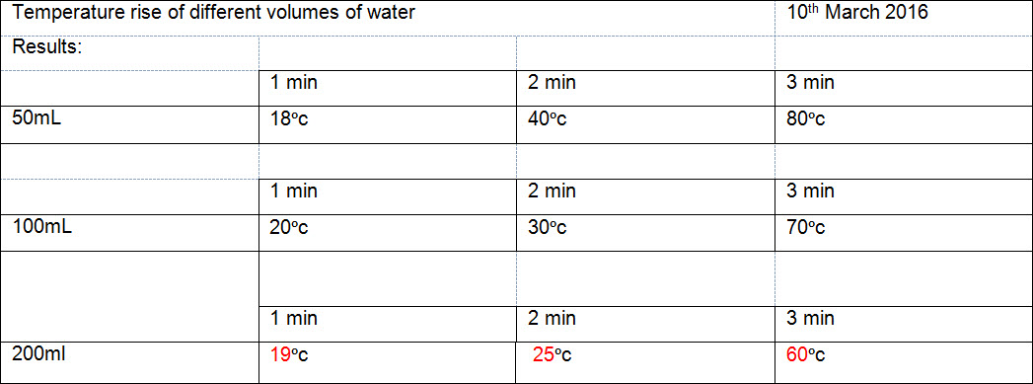

Word detective

3 True or false

Read each of the following statements and indicate whether it is true or false.

1 The main purpose of a logbook is for a scientist to draw in.

F

2 It is important to label a logbook with your contact details.

T

3 Bound notebooks are more reliable that electronic device logbooks.

F

4 You should date every entry you make in your logbook.

T

5 It is more important to record your data and observations in your logbook than to avoid errors.

T

6 Your logbook entries will give you all the details to write up a formal report, if required.

T

1.5 Tables and graphs are used to present scientific data

Literacy support worksheet answers (pages 12–13)

Graphing and interpreting data

1 What are four common features in graphs?

a A descriptive title of what the graph shows

b A grid that is used to plot the points or data

c The independent variable on the horizontal axis

d The dependant variable on the vertical axis

2 What is the most common type of graph, used to represent data, in science?

A line graph

3 A student put two chemicals together and recorded the temperature of the reaction for eight minutes.

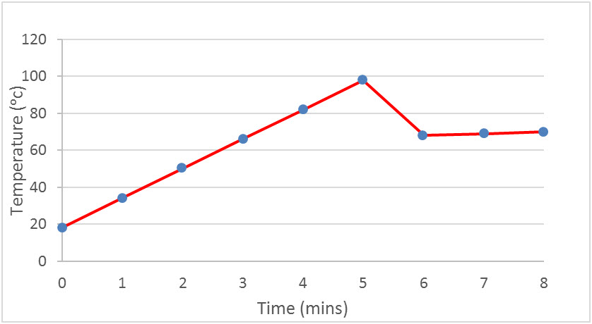Create a line graph for the following set of data.

|  |  |
| --- | --- |
| Time (mins) | Temperature (ᵒc) |
| 0 | 20 |
| 1 | 30 |
| 2 | 40 |
| 3 | 50 |
| 4 | 60 |
| 5 | 65 |
| 6 | 68 |
| 7 | 69 |
| 8 | 70 |

a What is the shape of the graph?

Positive slope upwards, but not directly proportional as it starts to plateau

b The independent variable is time and the dependent variable is temperature.

Complete the following sentence:

As the time increases, the temperature increases.

c Use a red pen to extrapolate the graph above.

Student responses will vary.

4 For most graphs you can calculate the slope of the graph as: 

(Rise= top Y point - bottom Y Point) (Run= top X point - bottom X Point)

A student heats water by using a Bunsen burner. Then they heat water using a hotplate.

a Graph the results of the two methods below:

|  |  |  |  |  |  |  |  |  |  |  |  |  |  |  |  |  |  |  |  |  |  |  |  |  |  |  |  |  |  |
| --- | --- | --- | --- | --- | --- | --- | --- | --- | --- | --- | --- | --- | --- | --- | --- | --- | --- | --- | --- | --- | --- | --- | --- | --- | --- | --- | --- | --- | --- |
| Bunsen burner:   |  |  | | --- | --- | | Time (min) | Temp (ᵒc) | | 0 | 18 | | 1 | 34 | | 2 | 50 | | 3 | 66 | | 4 | 82 | | 5 | 98 | | Hotplate:   |  |  | | --- | --- | | Time (min) | Temp (ᵒc) | | 0 | 18 | | 1 | 26 | | 2 | 34 | | 3 | 42 | | 4 | 50 | | 5 | 58 | |
| b In each of the boxes below, calculate the slope of the graphs above: | |
|  |  |

Word detective

5 Matching meaning

Draw a line to match the words on the left to the description on the right.

